The specification:
Create below tables in sql:
Task (id, name, desc, tasktypeId, isactive, lastupdated, lastupdateby)
TaskType (id, name, desc, lastupdated, lastupdatedby)
Create a CRUD screen for Task using MVVM/EF/Kendo UI Razor

GitHut URL: https://github.com/YPhyu/Exercise.git
Prerequisite: Visual Studio 2015, SQL Server 2012 LocalDB, NuGet Package Manager
Languages/Framework:
.NET 4.6, C#, ASP.NET MVC, Razor, AngularJS, SB Admin Bootstrap, Kendo UI AngularJS, Entity Framework Code Frist Approach

Screenshots:
Login Page

I added the sample data for authentication, task types and task at the initial setup using code first approach. The username and password to login are as below:

Username: jane.doe@me.com
Password: Password1

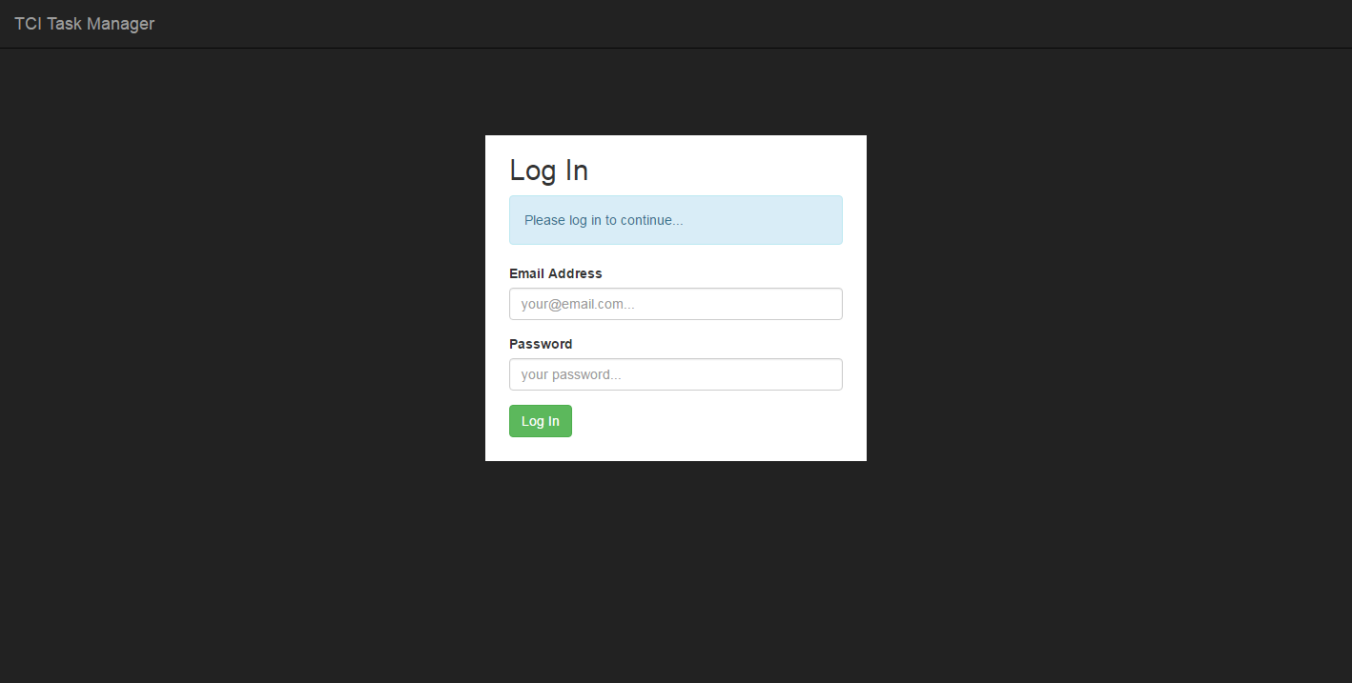
Home Page

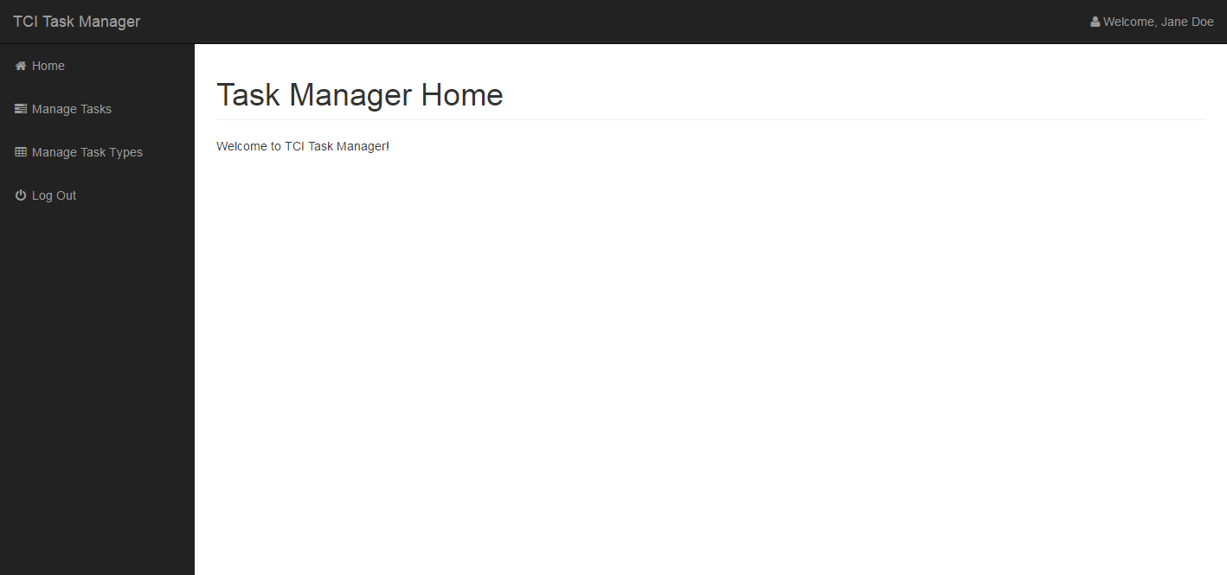

Manager Task

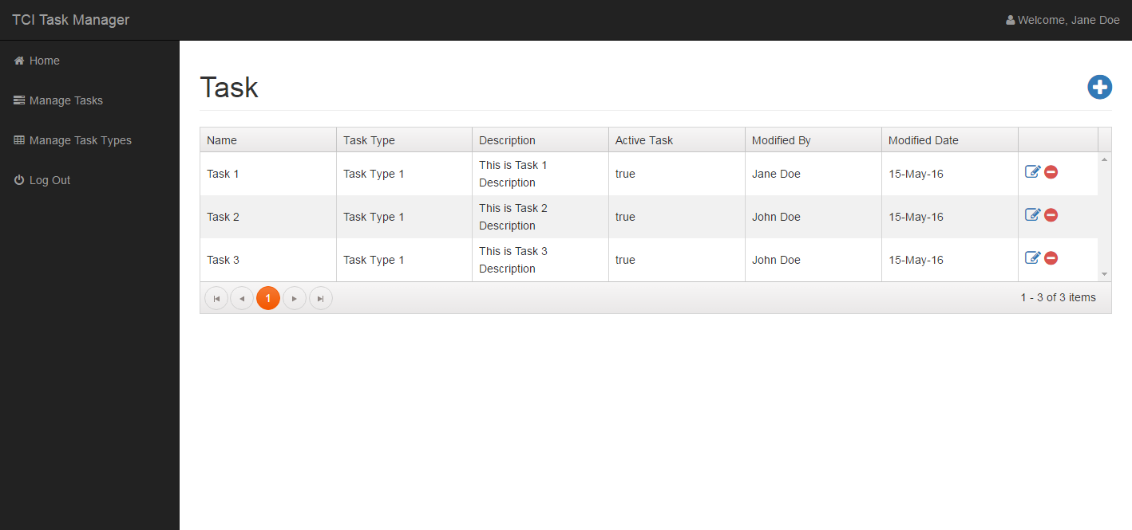
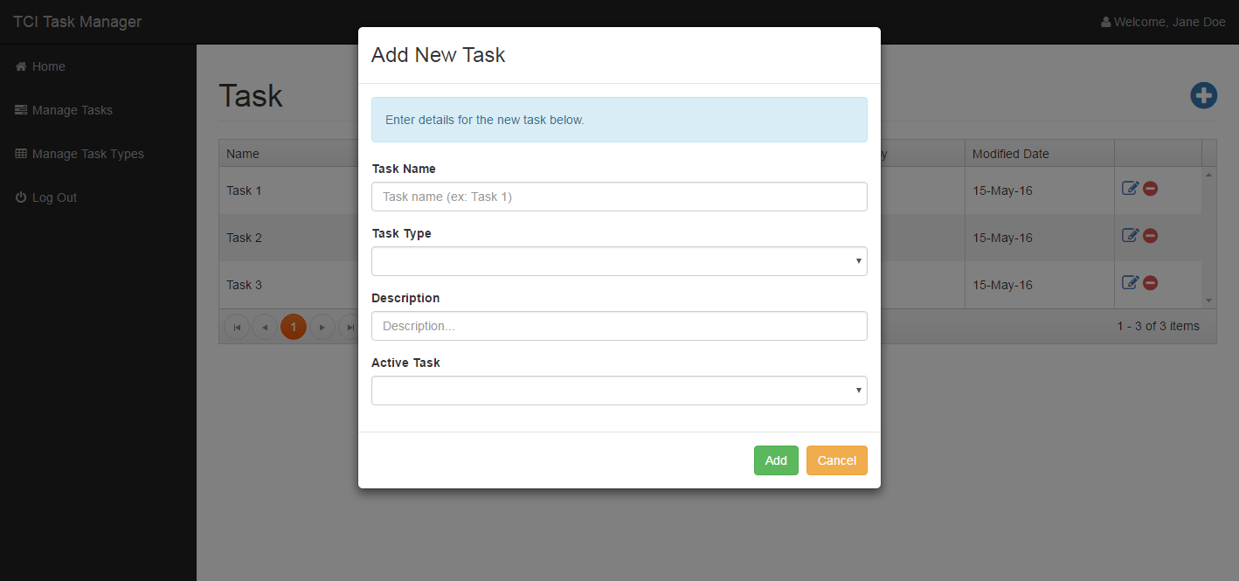

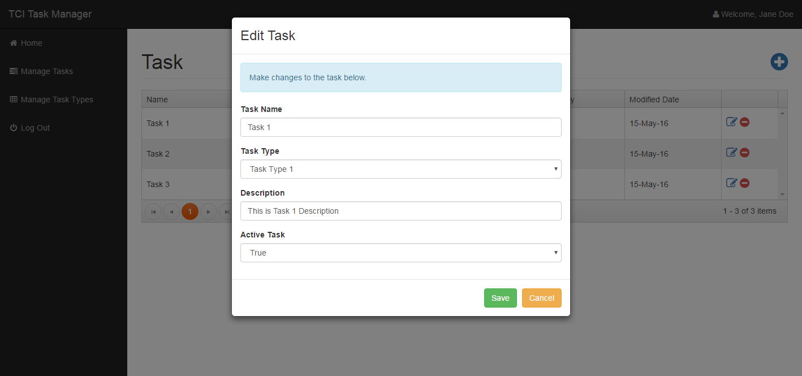
Manage Task Type

